Assignment : Network cable and connector

Draw a labeled diagram of a Cat6 Ethernet cable, showing the color order of wires in the T568B standard and labeling the RJ-45 connector pins.

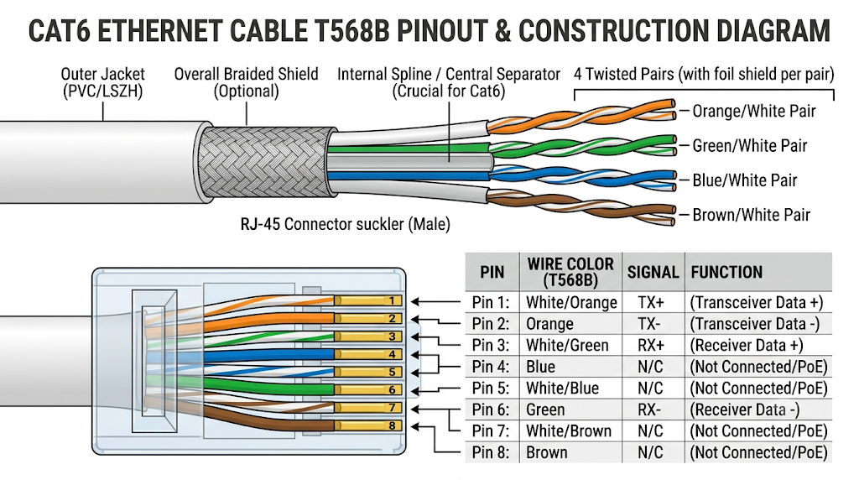

List three types of network cables (such as Cat5e, Cat6, and fiber optic) and for each, mention one real-world app or device (like a WiFi router, Zomato POS terminal, or IPL streaming server) where it would be used, explaining why.
Ans :
- Cat5e Cable (PoS Terminal / Payment Machine)

  - Device: Zomato or Swiggy Point-of-Sale (POS) counter terminal.

  - Why: Point-of-sale systems require low bandwidth (transferring basic transaction data and text receipts) but rely heavily on low latency and rock-solid stability to process payments instantly. Cat5e supports up to 1 Gbps speed over short distances, making it a cost-effective and reliable choice for steady, everyday business hardware.

- Cat6 Cable (Home WiFi Router)

  - Device: High-speed Gigabit WiFi Router or Gaming PC.

  - Why: Modern home internet plans frequently exceed 100 Mbps, and local networks handle heavy local traffic like 4K streaming or NAS file transfers. Cat6 features tighter wire twisting and a central spline to reduce crosstalk, allowing full 1 Gbps to 10 Gbps speeds over shorter distances (up to 55 meters) with minimal signal interference.

- Fiber Optic Cable (Live Sports Streaming Server)

  - Device: Hotstar / IPL Streaming Media Server or Data Center Backbone Switch.

  - Why: Delivering high-definition, real-time video streams to millions of concurrent users requires massive bandwidth (10 Gbps to 100+ Gbps) over long distances without attenuation. Fiber optic cables transmit data using light signals rather than electrical currents, rendering them immune to electromagnetic interference and capable of carrying massive data volumes over long distances with virtually zero signal loss.

Watch a YouTube video showing how to crimp an RJ-45 connector onto a network cable, then write down the step-by-step process in your own words and mention two common mistakes to avoid.
Ans :
Based on the tutorial video "How to Crimp Cat5 / Cat6 Network Patch Cables (RJ45 plugs)" by Switched On Network, here is the step-by-step process for crimping an RJ-45 connector onto a network cable along with key mistakes to avoid:
Step-by-Step Crimping Process
- Slide on the Strain Relief Boot: Before doing anything else, slide a protective strain relief boot onto the raw cable.
- Strip the Outer Jacket: Strip roughly 3 cm (~1.2 inches) of the outer PVC jacket off the cable using a mini wire stripper, taking care not to nick or damage the inner conductors.
- Remove Extra Core Material: Trim off the internal plastic central separator (spline) and the rip-cord thread running along the wires.
- Untwist and Straighten the Wires: Untwist all four pairs. You can use the stripped piece of outer jacket to slide between pairs to untwist them easily. Pinch and flatten each individual wire with your fingers to straighten them out.
- Arrange Wires by Pinout Standard: Line up the eight wires in the T568B standard order (from left to right with the RJ-45 clip facing away from you):
  - Pin 1: White/Orange
  - Pin 2: Orange
  - Pin 3: White/Green
  - Pin 4: Blue
  - Pin 5: White/Blue
  - Pin 6: Green
  - Pin 7: White/Brown
  - Pin 8: Brown
- Trim to Length: Hold the RJ-45 plug up against the exposed wires to measure. Trim the wires flush in a clean straight line so that all 8 wires will reach the very tip of the connector while allowing the outer jacket to sit inside the plug.
- Insert Wires into the Connector: Carefully slide the bunched, straight wires into the RJ-45 plug (with the clip tab facing down/away). Ensure every wire reaches the front end under the copper contact pins.
- Crimp the Plug: Insert the connector into the crimping tool slot and squeeze firmly. This pushes the copper pins down into the individual wires and clamps the strain-relief latch down onto the outer cable jacket.
- Slide Boot & Test: Slide the strain relief boot up over the plug clip. Use an Ethernet cable tester to confirm that all eight pins (1 to 8) illuminate sequentially on both ends.
2 Common Mistakes to Avoid
- Cutting Wires Too Long (Exposing Outer Jacket Outside the Connector):
  - Mistake: Leaving too much length on the individual exposed wires so that the outer jacket remains outside the RJ-45 housing.
  - Consequence: The crimp tool’s internal clamp won't grip the cable jacket, placing all mechanical strain directly on the thin individual wires, leading to eventual breakage or signal dropouts.
- Failing to Push Wires All the Way to the Front Tip:
  - Mistake: Not sliding the wires deep enough into the plug prior to squeezing the crimping tool.
  - Consequence: The copper pin contacts won't pierce or make electrical contact with all eight wires, resulting in a failed connection or a drop in link speed from Gigabit down to 100 Mbps (or no signal at all).

Given the following scenario: You are setting up a gaming zone for an IPL screening event and need to connect multiple screens and consoles. Choose the appropriate cable and connector types for high-speed, reliable connections, and explain your choices.
Ans :
Network Infrastructure (Console & Streaming Connectivity)
- Cable Type: Cat6a Ethernet Cable
- Connector Type: RJ-45 (T568B Standard)
- Why: Online multiplayer consoles and high-bitrate live IPL stream boxes demand ultra-low latency and steady packet delivery. Cat6a supports speeds up to 10 Gbps and a bandwidth of 500 MHz over distances up to 100 meters. Its enhanced internal shielding prevents crosstalk and signal interference caused by power cords running across a busy venue.
Short-Range Display Setup (Console to Nearby Screen)
- Cable Type: Ultra High Speed HDMI 2.1 Cable (Passive)
- Connector Type: Standard HDMI Type-A
- Why: HDMI 2.1 delivers up to 48 Gbps bandwidth, enabling 4K resolution at 120Hz. This is essential for modern gaming consoles (PS5, Xbox Series X) to utilize Variable Refresh Rate (VRR) and Auto Low Latency Mode (ALLM) for buttery-smooth gameplay without screen tearing.
Long-Distance Display Setup (Overhead Screens & Main Stage Displays)
- Cable Type: Active Optical HDMI 2.1 (AOC) Cable or HDMI over HDBaseT Extender (Cat6a)
- Connector Type: HDMI Type-A / RJ-45
- Why: Standard passive HDMI cables lose signal integrity over distances greater than 3 to 5 meters. Active Optical HDMI cables convert electrical video signals into fiber-optic light pulses, transporting uncompressed 4K/120Hz content up to 30+ meters without latency or signal degradation. For extreme runs across a hall, HDBaseT extenders run the HDMI feed over durable Cat6a network cables.

Find and share a photo (from your home, college, or online) of any network cable or connector in use (such as behind a WiFi router or at a café's POS counter), and describe what type it is and what devices it connects.<br><br><em><strong>Hint:</strong> Look for blue or yellow cables with clear plastic ends (RJ-45) or thin round cables for fiber optics.</em>
Ans :
Cable Description & Connection Details
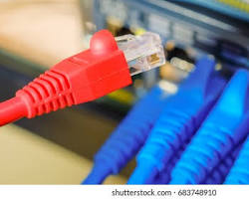
- Cable Type: Cat6 Unshielded Twisted Pair (UTP) Ethernet Cable

- Connector Type: RJ-45 (Registered Jack 45) Male Connector

- Devices Connected:

  - Source: A Wi-Fi Router / Fiber ONT Modem (shown on the receiving end).

  - Destination: Connects to a Desktop PC, Gaming Console, Smart TV, or PoS (Point of Sale) terminal.

Key Features Visible in the Image:
- Clear Plastic RJ-45 Plug: You can see the transparent housing with a flexible locking clip/tab at the top that snaps into the LAN port to keep the connection secure.

- Individual Color-Coded Wires: Inside the clear connector head, the eight individual insulated copper wires are visible, aligned side-by-side according to standard pinouts (such as T568B) so the internal gold contacts can pierce into them for electrical conductivity.

- Blue Outer PVC Jacket: Protects the inner twisted pairs from physical wear and environmental damage while keeping cable crosstalk to a minimum.

